(b)

n <- 100  
x <- c(0,100,1)  
a <- rnorm(n)  
x[1] = 0  
  
for (t in 2 : 101)   
x[t] <- 0.5 * x[t-1] + a[t]  
plot(x)

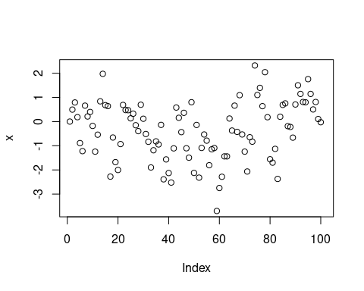

(c)

theta_vector <- c()  
n <- 10 # k = 10  
for ( N in 1 : 500 ) #N =500  
{  
x <- c(0, n, 1)  
a <- rnorm(n + 1)  
x[1] = 0  
  
for (t in 2 : n+1)   
x[t] <- 0.5 * x[t-1] + a[t]  
  
z <- 0  
for (i in 2 : n+1)  
{  
z <- z + x[i - 1]*x[i]   
}  
  
theta <- z / sum(x ^ 2)  
theta_vector <- c(theta_vector, theta)  
}  
  
hist(theta_vector)

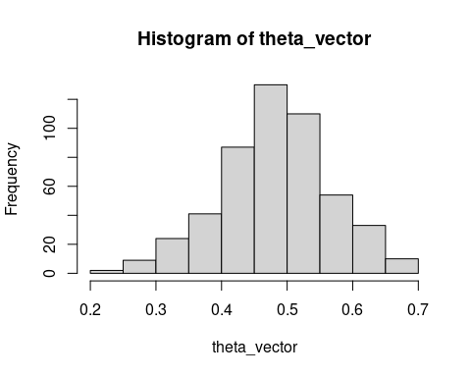

theta_vector <- c()  
n <- 100 # k = 100  
for ( N in 1 : 500 ) #N =500  
{  
x <- c(0, n, 1)  
a <- rnorm(n + 1)  
x[1] = 0  
  
for (t in 2 : n+1)   
x[t] <- 0.5 * x[t-1] + a[t]  
  
z <- 0  
for (i in 2 : n+1)  
{  
z <- z + x[i - 1]*x[i]   
}  
  
theta <- z / sum(x ^ 2)  
theta_vector <- c(theta_vector, theta)  
}  
  
hist(theta_vector)

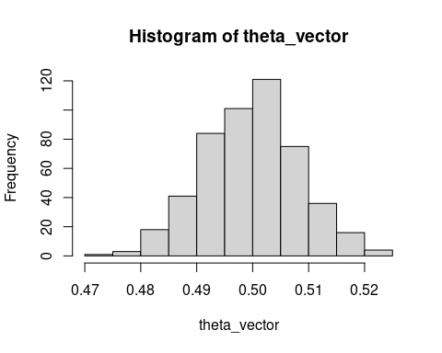

theta_vector <- c()  
n <- 1000 # k = 1000  
for ( N in 1 : 500 ) #N =500  
{  
x <- c(0, n, 1)  
a <- rnorm(n + 1)  
x[1] = 0  
  
for (t in 2 : n+1)   
x[t] <- 0.5 * x[t-1] + a[t]  
  
z <- 0  
for (i in 2 : n+1)  
{  
z <- z + x[i - 1]*x[i]   
}  
  
theta <- z / sum(x ^ 2)  
theta_vector <- c(theta_vector, theta)  
}  
  
hist(theta_vector)

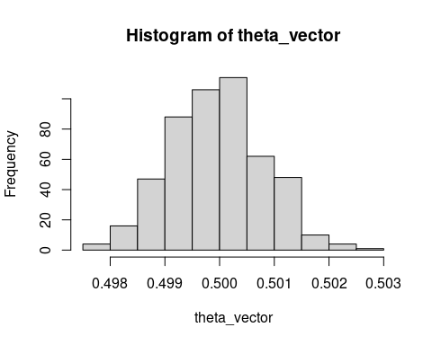

theta_vector <- c()  
n <- 5000 # k = 5000  
for ( N in 1 : 500 ) #N =500  
{  
x <- c(0, n, 1)  
a <- rnorm(n + 1)  
x[1] = 0  
  
for (t in 2 : n+1)   
x[t] <- 0.5 * x[t-1] + a[t]  
  
z <- 0  
for (i in 2 : n+1)  
{  
z <- z + x[i - 1]*x[i]   
}  
  
theta <- z / sum(x ^ 2)  
theta_vector <- c(theta_vector, theta)  
}  
  
hist(theta_vector)

